Ethan Mills

CS-255

Southern New Hampshire University

October 03, 2024

CS 255 Business Requirements Document Template

Complete this template by replacing the bracketed text with the relevant information.

This template lays out all the different sections that you need to complete for Project One. Each section has guiding questions to prompt your thinking. These questions are meant to guide your initial responses to each area. You are encouraged to go beyond these questions using what you have learned in your readings. You will need to continually reference the interview transcript as you work to make sure that you are addressing your client’s needs. There is no required length for the final document. Instead, the goal is to complete each section based on your client’s needs.

**Tip:** You should respond in a bulleted list for each section. This will make your thoughts easier to reference when you move into the design phase for Project Two. One starter bullet has been provided for you in each section, but you will need to add more.

System Components and Design

Purpose

*What is the purpose of this project? Who is the client and what do they want their system to be able to do?*

* Liam wants to take advantage of the void in the market for training students for drivers tests(SNHU, n.d.). He wants to provide a better resource for students to better help bring down the amount of people failing driver's tests(SNHU, n.d.). He wants to bring on the road training and wants a system to better help assist him do just that(SNHU, n.d.). With this system he wants to be able to access the data from anywhere and online and offline(SNHU, n.d.). But moving forward from that he will not be able to access the data if he is offline(SNHU, n.d.).

System Background

*What does DriverPass want the system to do? What is the problem they want to fix? What are the different components needed for this system?*

* He wants to be able to access the data from any device whether that is via mobile or desktop(SNHU, n.d.). They want to fix the failing drivers tests numbers via the training that drivers pass will offer(SNHU, n.d.). He also wants to be able to access all accounts knowing when someone makes a reservation, who canceled, who modified the order to be able to see who and what went wrong and when(SNHU, n.d.). The system needs to be able to run off of the web and probably over a cloud service to be able to access from anywhere and any device with a provided connection(SNHU, n.d.).

Objectives and Goals

*What should this system be able to do when it is completed? What measurable tasks need to be included in the system design to achieve this?*

* The system should be able to schedule appointments, cancel appointments, amend appointments and be able to display all of that information for the owner whenever and wherever on any device so long as there is an internet connection(SNHU, n.d.). For the owner side it should be able to provide all of the previous information along with information about the client to be able to reach them either via mail or cellphone(SNHU, n.d.). Measurable task that needs to be included in this system design is allocating enough space from the best cloud service to be able to store all the necessary data that is needed from the clients(SNHU, n.d.).

Requirements

Nonfunctional Requirements

*In this section, you will detail the different nonfunctional requirements for the DriverPass system. You will need to think about the different things that the system needs to function properly.*

Performance Requirements

*What environments (web-based, application, etc.) does this system need to run in? How fast should the system run? How often should the system be updated?*

* The system needs to run in a web based cloud environment to meet the needs of the client who wants to be able to access the system from anywhere at any time so long as there is an internet connection. The system needs to be fast and accurate with minimal loading time preferably no longer than 5 seconds. Like with any program, application or in this case a web based cloud environment, needs to stay up to date with all updates to ensure the program runs correctly and security is kept up to date.

Platform Constraints

*What platforms (Windows, Unix, etc.) should the system run on? Does the back end require any tools, such as a database, to support this application?*

* For this project I believe that the system should be able to run off of any operating system and run on any browser. For example, Google Chrome, Microsoft Edge, Firefox and safari. With the system being required to store all customer and non customer data on the cloud server, backup should not have to be a concern.

Accuracy and Precision

*How will you distinguish between different users?* *Is the input case-sensitive? When should the system inform the admin of a problem?*

* With this type of system, each user will have an individual unique one of one user login and password. When it comes to the administration roll, depending on the extent of the roll either access to everything appropriate or the bare minimum they will have their own login and permissions on the cloud server much different that the customers permissions. Just like with any program or application that requires a password and username to login, ensuring that there is no same username or email are used and that the passwords and username are case sensitive to increase security for both clients and employees. When it comes to any sort of breach or suspicious activity or problem, all admins should be notified immediately.

Adaptability

*Can you make changes to the user (add/remove/modify) without changing code? How will the system adapt to platform updates? What type of access does the IT admin need?*

* Since the user data is all stored on the cloud based system, the code in theory should not require any type of modification once completed. With the cloud web based cloud system applying updates should be no problem to implement at any time. The IT admin in this example needs to be able to access anything that is in the system. I also believe that a ranking system for admins should be available so that only a select few have the ability to see everything in the system that is also including all of customer information. While on the other end an admin role for the vast majority or admins to be able to do basic admin duties while also not having access to crucial parts of the application.

Security

*What is required for the user to log in? How can you secure the connection or the data exchange between the client and the server? What should happen to the account if there is a “brute force” hacking attempt? What happens if the user forgets their password?*

* I believe offering the option for both email and username would be a good quality of life option for our users in the example. Also including a password with case sensitive included. To secure the interaction between user and the server offering a multi factor authentication would be a good and easy route to go, for both developers and future users. To help prevent “hackers” from attempting to access someones account, I believe implementing a limitation to the number of login attempts and when that limitation is reach, there needs to either be a process the account owner goes through for example they get a email or text about it, verify if it is them, if not then they need to change their password. If there are any problems, customer support can help as well. If a user forgets their password they can select the forgot password option given to them on the login screen which will guide them to input the phone number and or email that is on file associated with that account. Once done they will receive a 4-8 digit code on said phone number or email to verify, once done they can change their password. If you wanted to go a step further before they can change their password after the email or phone number pin, they would have to answer a security question like “who was your 7th grade teacher” for example. In all this administrators wil also be notified about the account log in attempts and or a password change.

Functional Requirements

*Using the information from the scenario, think about the different functions the system needs to provide. Each of your bullets should start with “The system shall . . .” For example, one functional requirement might be, “The system shall validate user credentials when logging in.”*

* Offer three different driving package offers.
* Display the courses completed by the user.
* Display user overall progress.
* Display upcoming reservations.
* Display all dmv requirements and include updates.
* Allow users to book appointments through the portal.
* Allow users to access all their personal information.
* Allow users to select a pickup location.
* Allow users to get information about the driver and the vehicle before booking.
* User login input validation.
* Allow admin access to see all reservations, past, booked and canceled.
* Allow users access to virtual courses.

User Interface

*What are the needs of the interface? Who are the different users for this interface? What will each user need to be able to do through the interface? How will the user interact with the interface (mobile, browser, etc.)?*

* Allow users to make reservations.
* Allow users to take virtual courses.
* Allow users to have access to DMV requirements and resources.
* Allow users to access applications through all devices with online connection.
* Users interested are users who are interested in the services that are provided by driverspass.
* Another use is admin who can view customers accounts and information along with the access. to reservations past, current and canceled.
* Users will need the ability to create, change and cancel reservations via the application.
* Admin users need to also have access to making changes to reservations.
* Users need the ability to select the package they want.
* Admin users need ability to download reports
* Admin users need the ability to help users change and or reset passwords.
* All users will access the application via web browser so long as they have an internet connection.

Assumptions

*What things were not specifically addressed in your design above? What assumptions are you making in your design about the users or the technology they have?*

* The subject that I saw that was not discussed as much as it was needed was what the actual user both custom and admin interface and how it looks. I am assuming that all customers have access to the internet and a web browser, I am also assuming that the system will be easy to navigate for all users and that customer support will be always available for customers and that the IT team will be able to manage and maintain the system.

Limitations

*Any system you build will naturally have limitations. What limitations do you see in your system design? What limitations do you have as far as resources, time, budget, or technology?*

* Limited number of Instructors.
* Limited number of administrators.
* Limited number of IT personnel.
* Limited number of vehicles available to use.
* Limited to internet connection availability for customers.
* Time to complete is also a limitation.
* Limit Budget from Driverpass.
* Technology Limitations if applicable.

Gantt Chart

*Please include a screenshot of the GANTT chart that you created with Lucidchart. Be sure to check that it meets the plan described by the characters in the interview.*

[Insert chart]

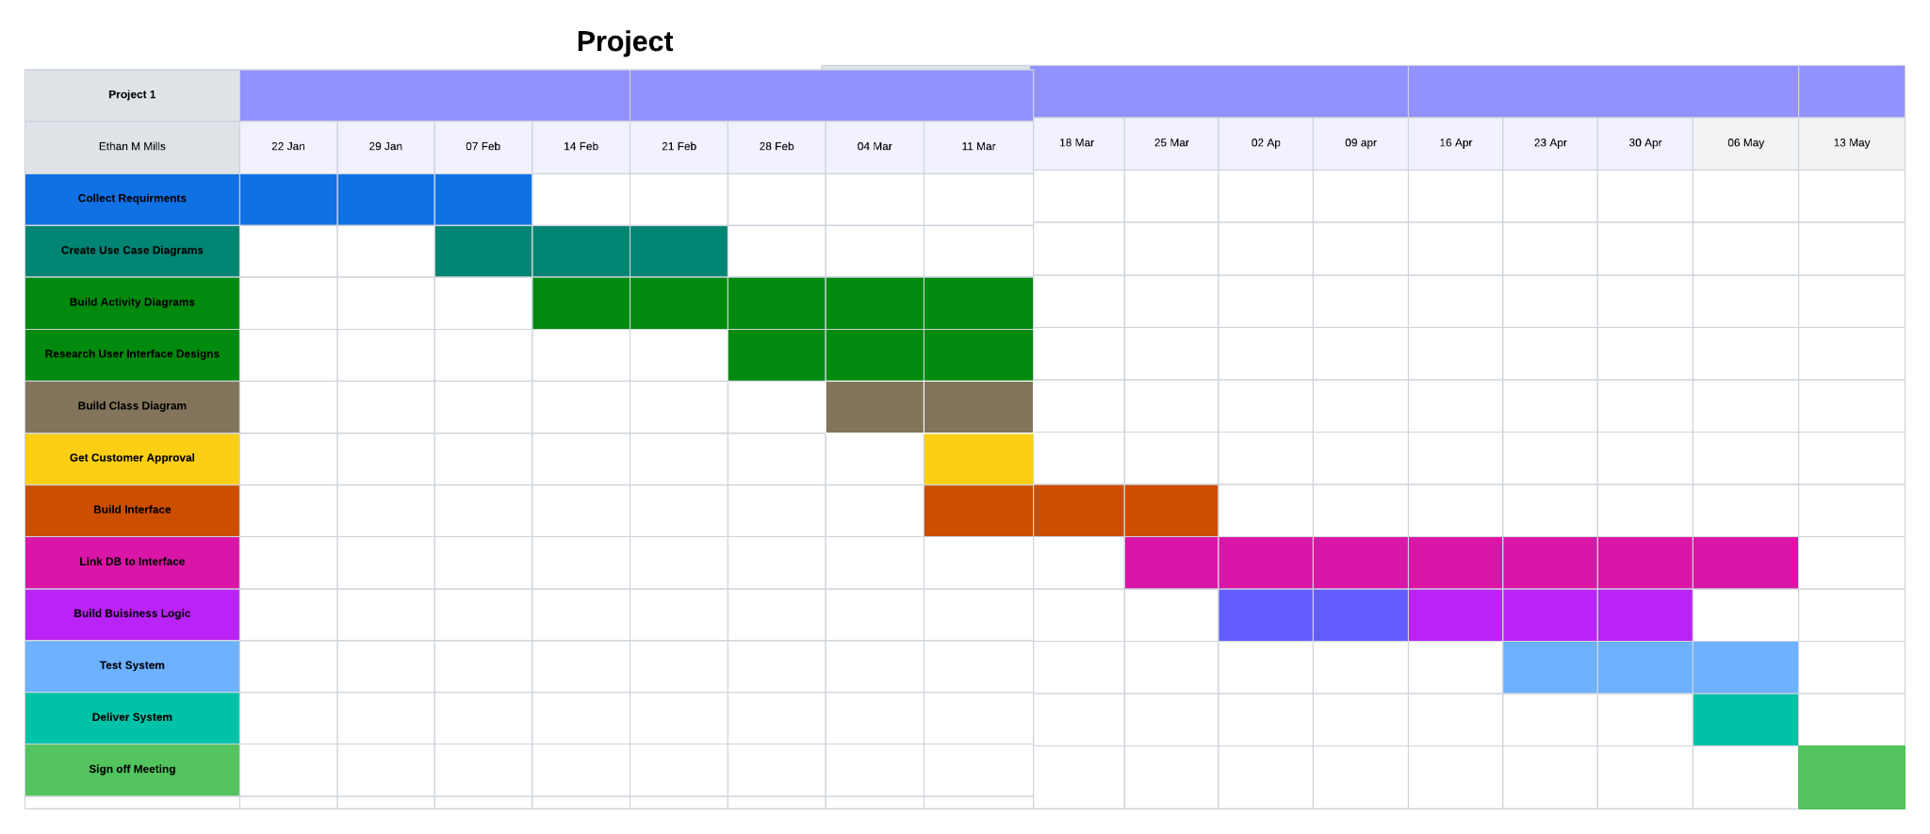

Work Cited

SNHU. (n.d.). *CS 255 DriverPass Interview Transcript.* Retrieved from https://learn.snhu.edu/content/enforced/1698519-CS-255-16946.202481-1/course_documents/CS%20255%20DriverPass%20Interview%20Transcript.pdf?ou=1698519